**TASK 7 – Launch a webpage using Amazon S3 service**

**AIM : To create and deploy a simple webpage using Amazon S3.**

**DESCRIPTION** : **Amazon S3** (Simple Storage Service) is a scalable, high-speed, low-cost web-based service designed for online backup and archiving of data and application programs. It allows to upload, store, and download any type of files up to 5 GB in size. This service allows the subscribers to access the same systems that Amazon uses to run its own web sites. The subscriber has control over the accessibility of data, i.e. privately/publicly accessible.

**PROCEDURE :**

**Step 1 :**

Open the Amazon S3 console from the following link

<https://console.aws.amazon.com/s3/home>**.**

**A dashboard will be opened as follows :**

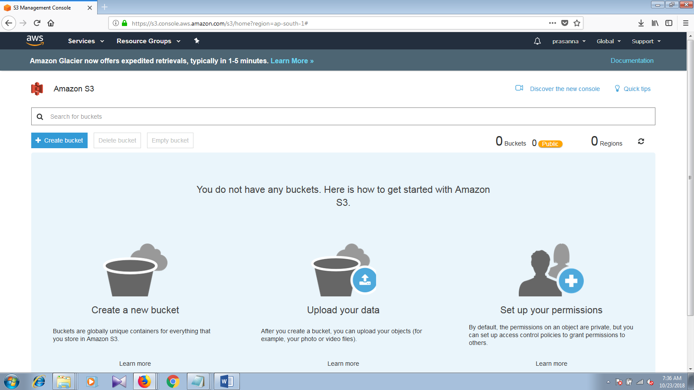

**Step 2** :

Create a bucket by clicking on the Create Bucket option.

A window will be opened asking for the name of the Bucket and configurations.

Set a unique name for the Bucket name and proceed with the default options.

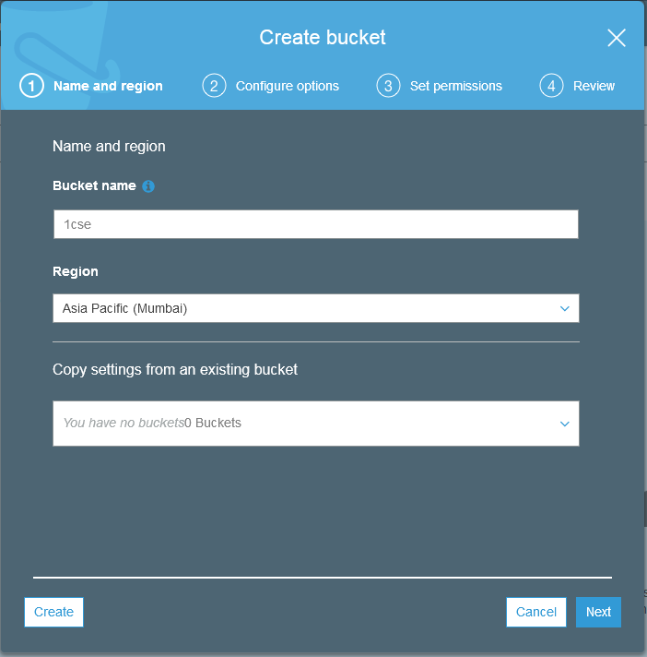

After the creation of the bucket it looks as follows :

Here we created a bucket with the name 1csecloud

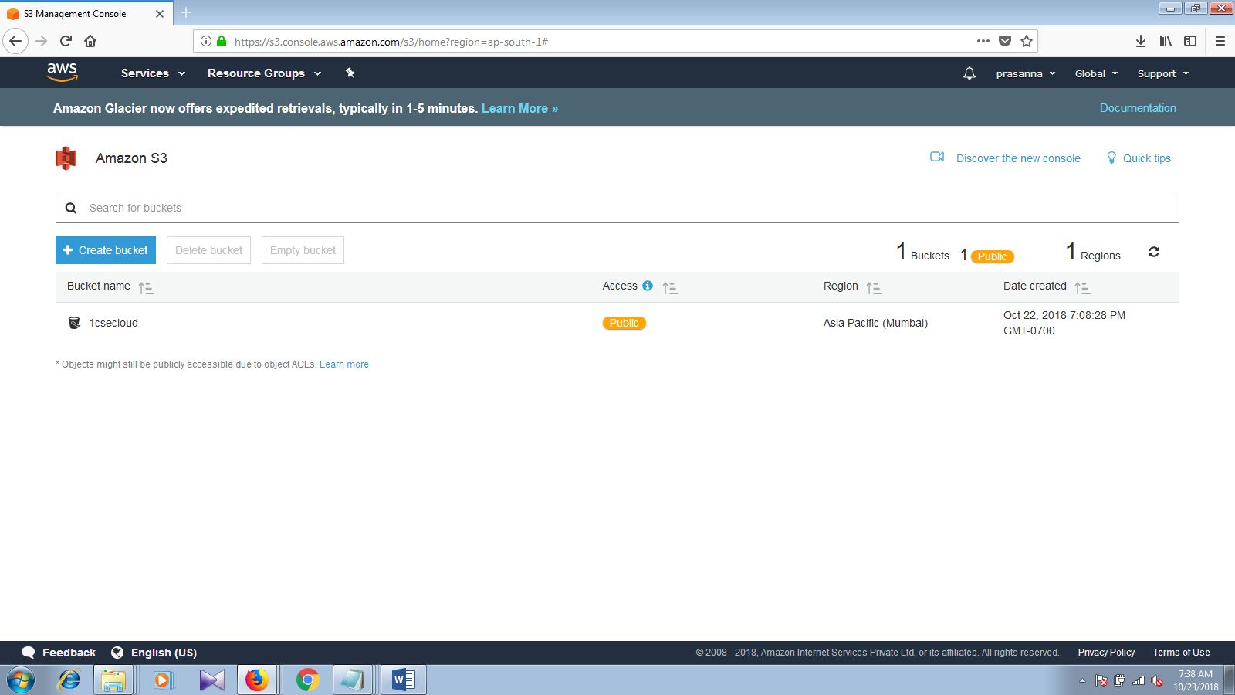

**Step 3 :**

Now click on the bucket and you will be asked to create a folder or upload the files directly which looks as follows:

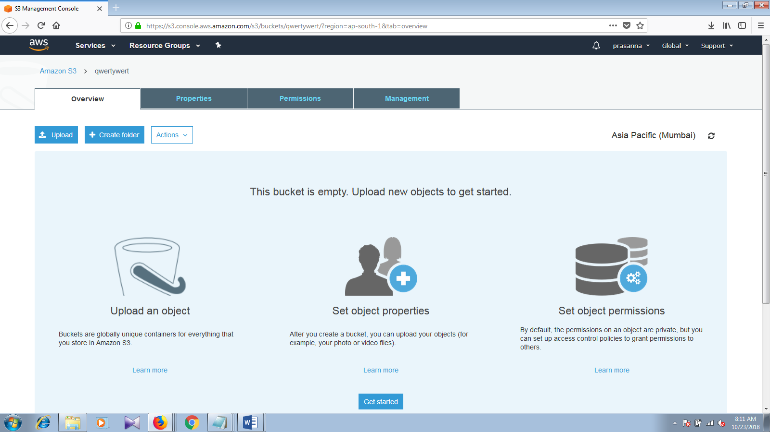

Now click on to the create folder button inorder to create a folder.

Here we create a folder with the name test.

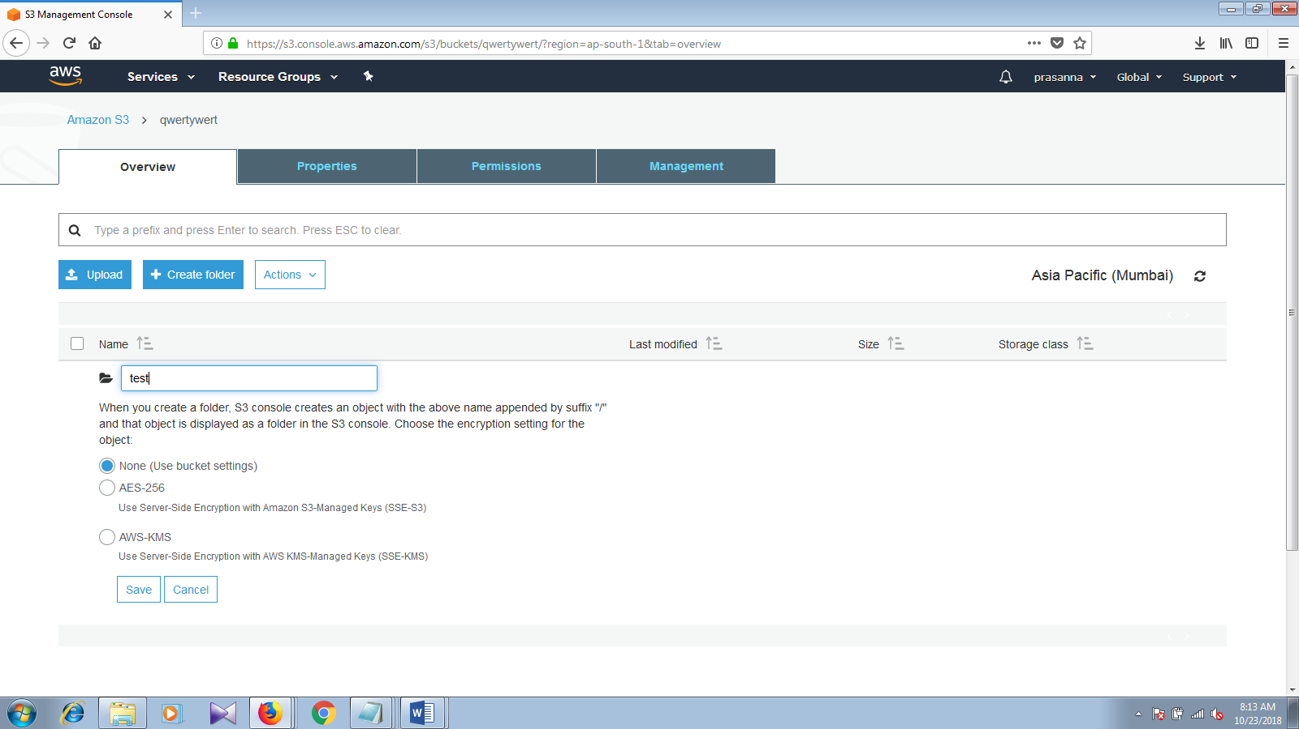

After creation of folder -> upload the files (here we upload a simple Html web page)

After uploading the page

Here we can see our webpage, Click on the file to open.

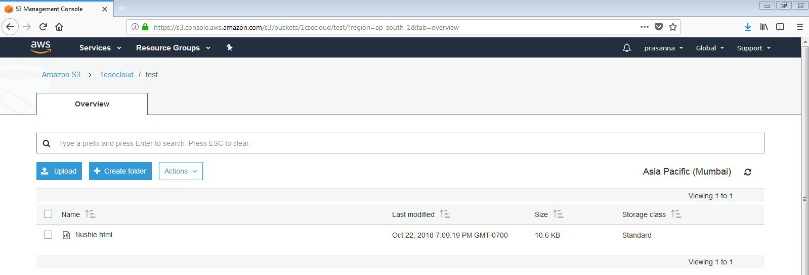

After opening the file we get the following :

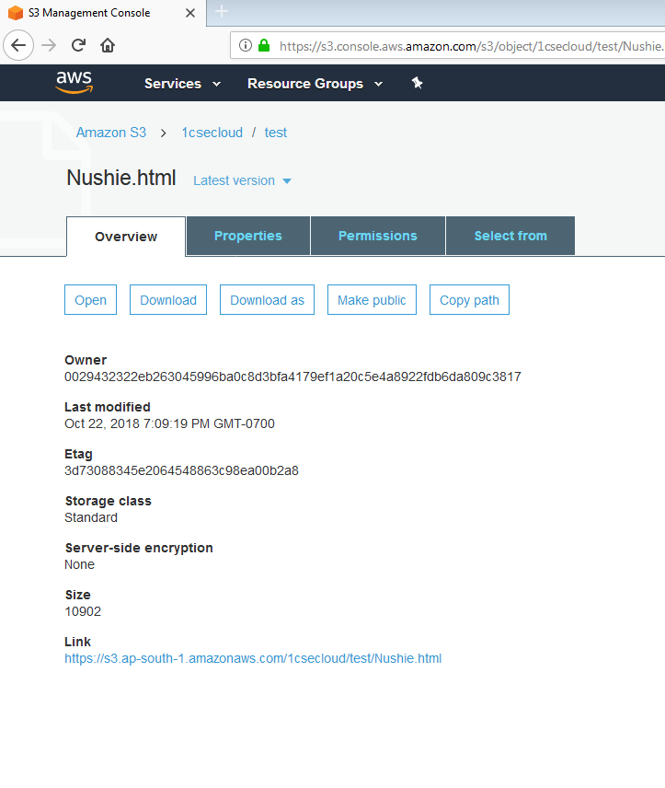

Now make the following application as public by clicking on Make public so that any one can see it .

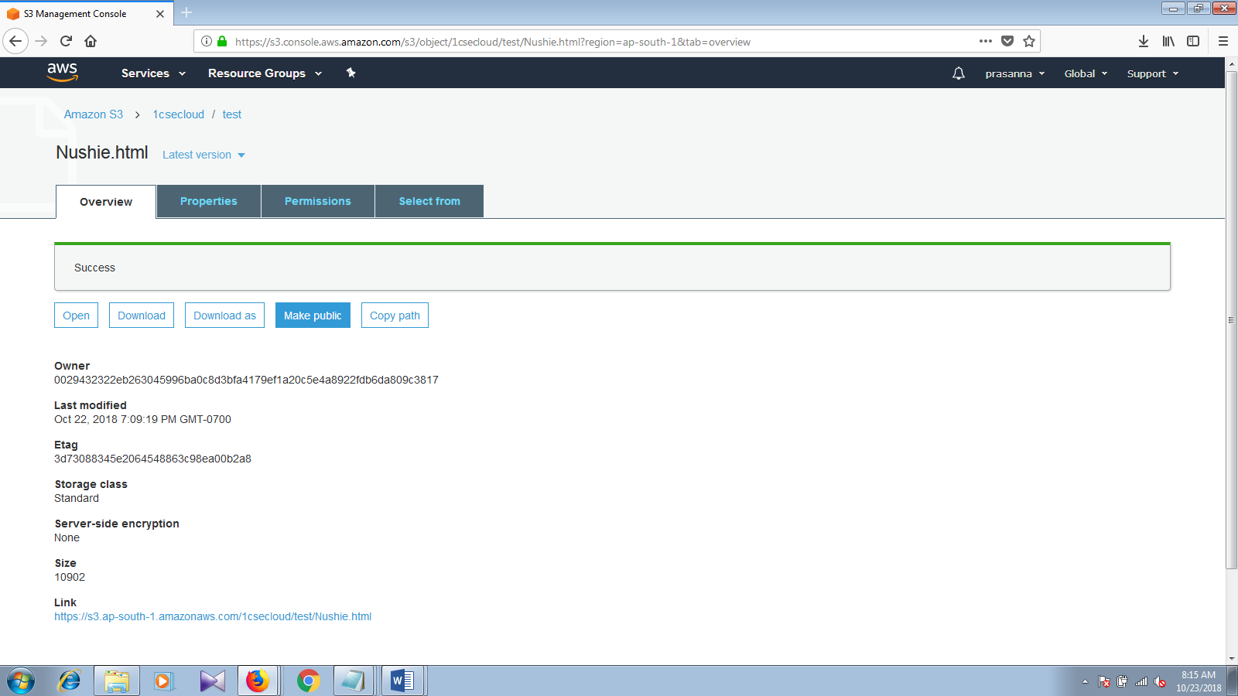

Link : <https://s3.ap-south-1.amazonaws.com/1csecloud/test/Nushie.html>

This is how the output ( webpage) looks like:





Result : Hence we deployed a web page using Amazon S3 successfully.